Lab 10

MIPS Assembly

(Floating Point Arithematic)

* Pre-Lab

1. Introduction

MIPS has a floating-point co-processor with its own 32 registers, $f0-$f31 (see the Coproc1 tab in the panel at right in MARS), and its own instruction set. Floating point data is represented using IEEE-754 format.

1. Floating-Point Representation(IEEE-754)

IEEE-754 defines two floating point representations, single and double precision.



Single Precision



Double Precision



Figure 1 (Bias=127 for Single-Precision and 255 for Double-Precision)

For example in order to represent 23.75 in Single Precision value.

* First convert it in to binary

23=101112

0.75 x 2 = 1 + 0.5

0.5 x 2 = 1 + 0

So, the binary value is 10111.112

* Normalize it. 10111.11 = 1.011111 x 24
* We have to determine sign, fraction and exponent to fill in the 32-bit single precision value

Sign= (-1)0 = +1 . So, Sign=0

Fraction = 1+0.011111 . So, fraction is 0.011111

Exponent-Bias = 4. So, Exponent= 4+Bias=4+127=131= 100000112

|  |  |  |
| --- | --- | --- |
| 0 | 10000011 | 01111100000000000000000 |

1. Floating point Instruction



Table 1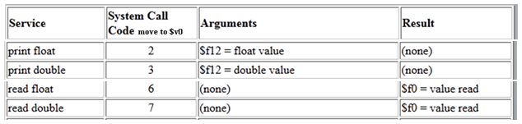

Table 2(Syscall)

Example Code:

The code below inputs radius and calculates area until its value is less than limit

.data

pi:.float 3.142

limit: .float 45.66

.text

lwc1 $f2, pi #load pi

lwc1 $f4,limit

loop:

li $v0,6 #get radius

syscall

mov.s $f1,$f0

mul.s $f1,$f1,$f1 # r*r

mul.s $f3,$f1,$f2 #Area =pi *r*r

c.lt.s $f3,$f4

bc1f loop

mov.s $f12,$f3

li $v0,2 #Display Area

syscall

* In-Lab
* Write a program that asks for number of subjects. It then gets grade and credit hour of each subject. Finally it displays the GPA
* Write a program that get GPA from a student and shows the grade.

|  |  |
| --- | --- |
| Grade | GPA |
| A (Excellent) | 4 |
| A - | 3.7 |
| B+ | 3.3 |
| B (Good) | 3.0 |
| B- | 2.7 |
| C+ | 2.3 |
| C | 2.0 |
| D (Minimum passing) | 1.3 |
| F | 0 |

* **Send your RegNo_Name_labno.doc at** [**khiyamiftikhar@gmail.com**](mailto:khiyamiftikhar@gmail.com) **with subject labno. Obviously replace ‘Reg’, ‘No’ and ‘Name’ in all these names with their values.**